MODULE 6 OUTPUT
Spring Data JPA - Quick Example
Country.java
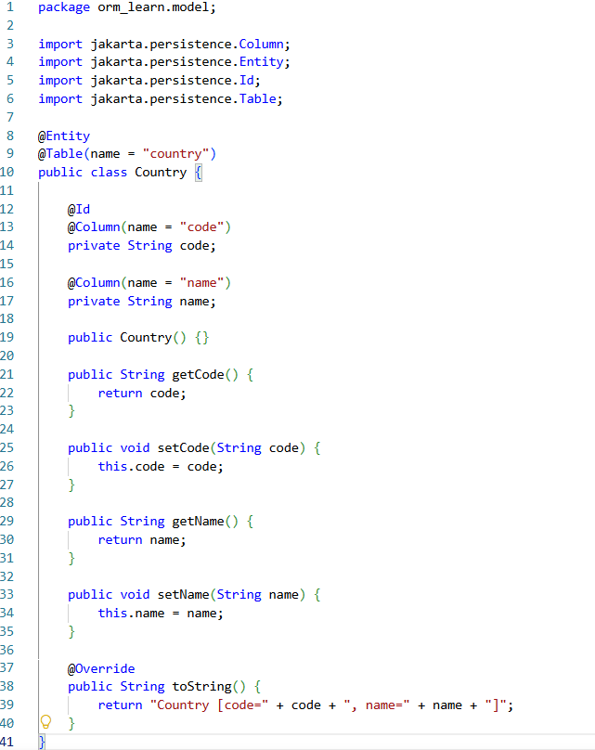
CountryRepository.java
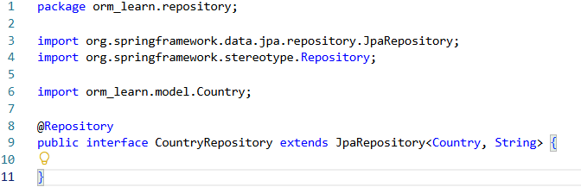
CountryService.java
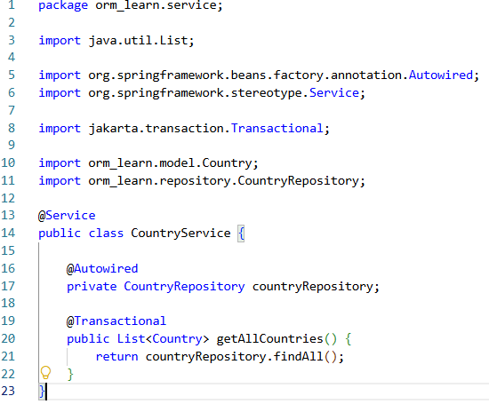
OrmApplication.java
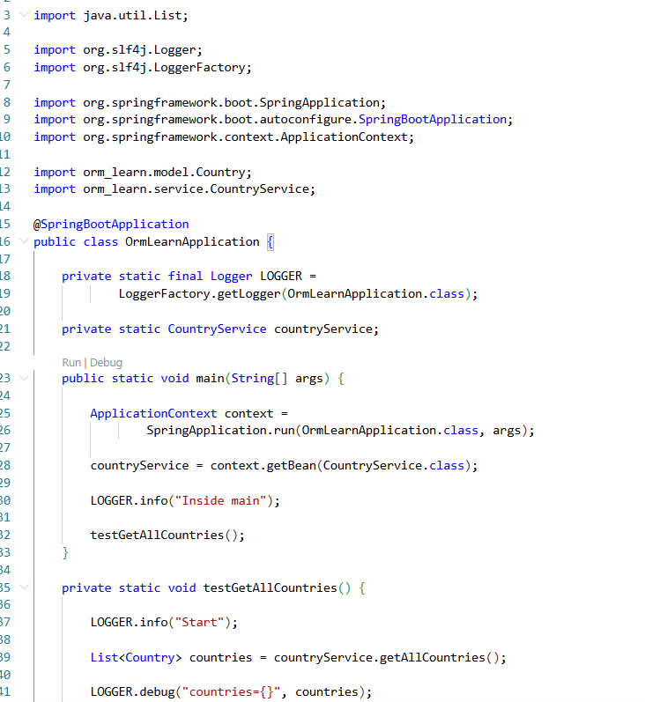
Output

